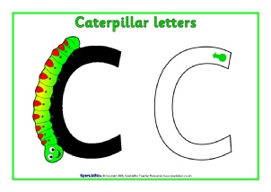
Handwriting patter- letter families
Curly caterpillar letters- those that start with a ‘c’:
c, a, o, d, g, q (e and s are close cousins of this family)

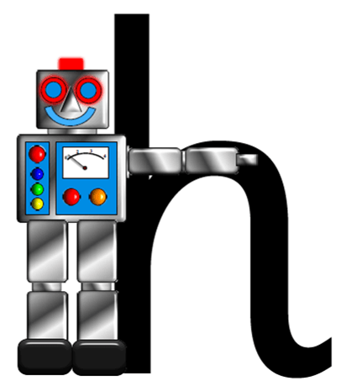
One-armed robot letters- those that start with an ‘r’, or a ‘down, up and over’:
r, n, m, (p, h, b are close cousins of this family)

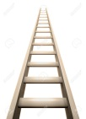
Long ladder letters- those that are ascenders:
b, h, k, l, t,

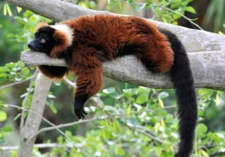
Dangly tail letters- those that are descenders:
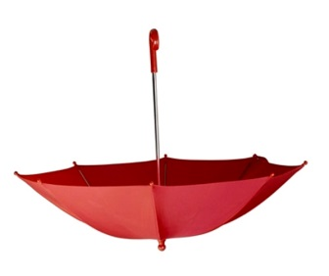
g, j, p, q, y

Upside down umbrella letters:
u, i, y

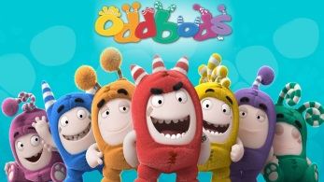
Odd bods:
f, x, z, v, w

